Name __________________
Strange Plants
Some plants are strange because they are surprising. They do things that most plants don’t do. One of these plants is called a tumbleweed. This big plant grows in dry grassland or at the end of a desert. Then the plant breaks off at the ground. It is ready to do something surprising. The plant can be blown far away by the wind! It might roll and roll for many miles. The plant drops its seeds everywhere it rolls.
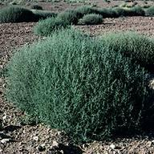
This is the tumbleweed plant. This tumbleweed rolls down a road.
This mimosa plant grows in warm places. It spreads its leaves to soak up sunshine. The plant stays in one place all its life. Part of the plant moves if a hungry animal touches it. The leaves quickly fold up tight and droop down! Then the leaves don’t look good to eat.
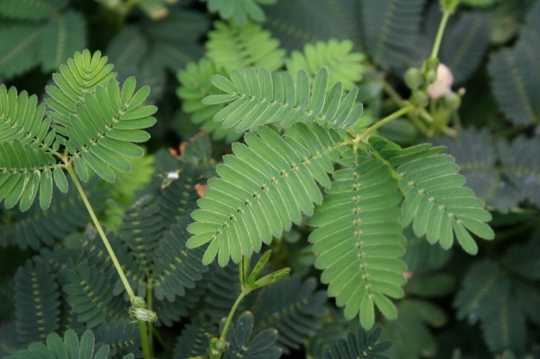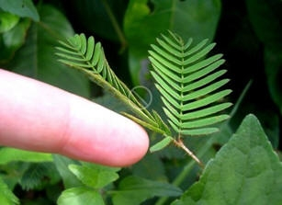
This plant is called a mimosa. This mimosa folds up its leaves.
Another plant has special leaves. The Venus fly trap lives in wet ground. The ground does not have enough nutrients or vitamins for the plant. The plant needs to trap an insect or spider. The plant has hairs along its leaves. Something happens if an insect touches the hairs two times. Snap! The leaf folds shut to trap the buggy meal.
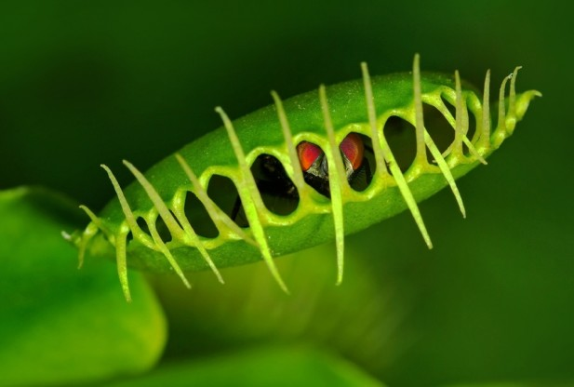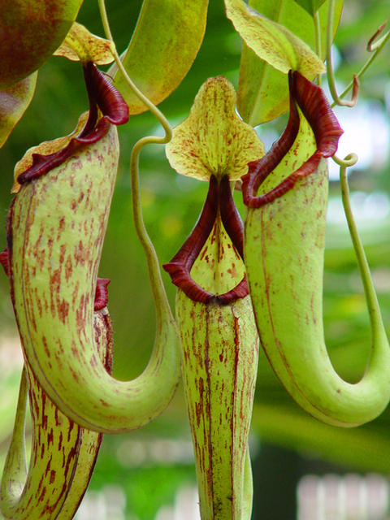
How do you think the Venus fly trap got its name? This plant is called a pitcher plant.
The pitcher plant has a surprise inside. Its leaves are long tubes with hairs. The tubes hold rainwater. Soon an insect will crawl into a tube. The plant hairs stop the insect from climbing out. The insect slides down the slippery tube and falls into the water! The plant has trapped its food.
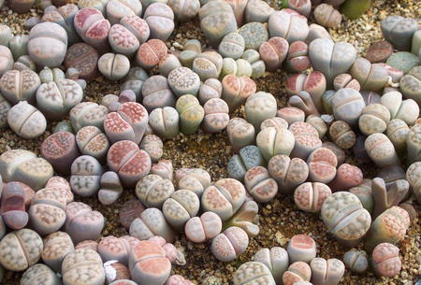
These plants are called living stones.
Watch your step. Some plants look like stones! You can just see the tips of leaves. Most of each leaf is in the ground. The color and shape of the leaves help the plants. The plants can hide next to rocks. Hungry animals don’t eat the plants if they can’t see them.
A cactus lives in a desert where the Sun is very hot. Most cactus plants have sharp spines that stop hungry animals. Look! This cactus has spines like long, white hair. The hairy spines protect the plant. The hot Sun does not reach and burn the plant.
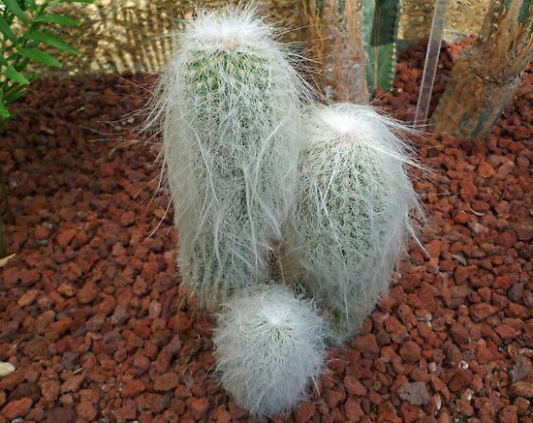
This cactus is called an old man cactus.
This is a very big plant from the jungle. Sometimes it opens to flower. Insects bring things to the plant that help the plant make seeds. This plant invites insects with its smell. But people think the smell is terrible! The smell is so strong that it can hurt a person’s nose for days.
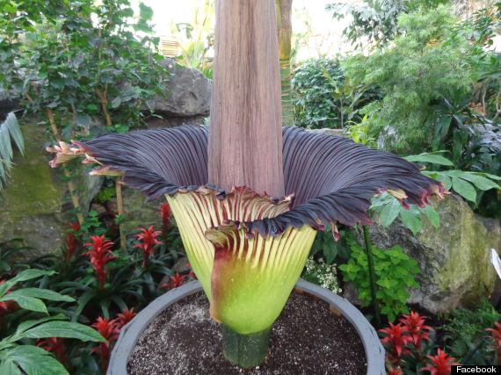
Some people call this a stinky flower.
Whether in finding interesting ways to protect themselves from animals, spread their seeds, or eat unusual things, some would say, “These plants are strange!”
Questions
Directions: Read the questions below. Then, use the highlighting tool to highlight the text that contains the answer to each question. (Reminder: Captions contain text.) Finally, answer the questions in complete sentences.
- Which plant is blown for miles?

- Which plant can hide next to rocks?

- Which two plants catch insects for food?

- What do people call the plant that can hurt a person’s nose for days?

- Cactuses, living stones, and mimosa plants all protect themselves from animals in different ways. Choose one and explain how they do it.

