Type Your Name: Type the Date:
(7 pts.)
- Highlight the word sandwich in grey highlighter. Highlight the word peanut in grey highlighter.
It is easy to make a peanut butter and jelly sandwich. First, find a loaf of bread. Next, spread peanut butter on the bread. Then, put jelly on your sandwich bread. Then, put the sandwich together. Finally, eat your peanut butter and jelly sandwich.
- Out of Order! PB&J
(5 pts.)
Directions: Look at the pictures which are out of order. Click and drag them into the correct order next to each number so the story makes sense. Don’t worry about moving to the next page.

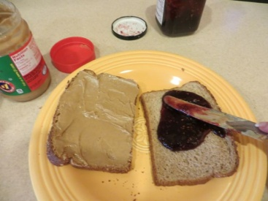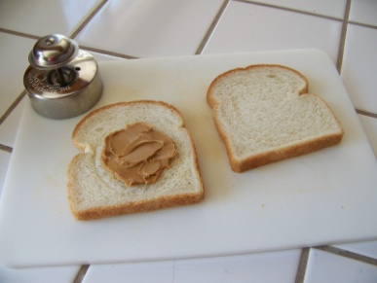
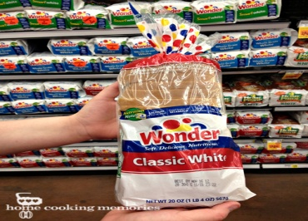
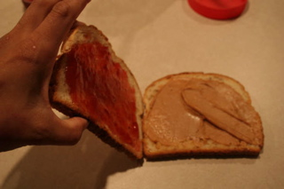

2.

3.

4.

5.

(4 pts.)
- Read the following paragraph to answer the question. Highlight the correct answer in grey.
It is easy to make a peanut butter and jelly sandwich. First, find a loaf of bread. Next, spread peanut butter on the bread. Then, put jelly on your sandwich bread. Then, put the sandwich together. Finally, eat your peanut butter and jelly sandwich.
What is the second step in making a peanut butter and jelly sandwich?
- Put the sandwich together
- Find a loaf of bread
- Put jelly on the bread
- Spread peanut butter on the bread
Copy and paste proof of your answer in the box below

Cut and paste the first sentence in this box

Highlight the proof in grey.

(4pts.)
Raise your hand and tell your teacher you are ready to type the story below. Retype the story just the way you see it! Use home keys and proper form.
Is it easy to make a peanut butter and jelly sandwich? First, find a loaf of bread. Next, spread peanut butter on the bread. Then, put jelly on your sandwich bread. Then, put the sandwich together. Finally, eat your peanut butter and jelly sandwich!

